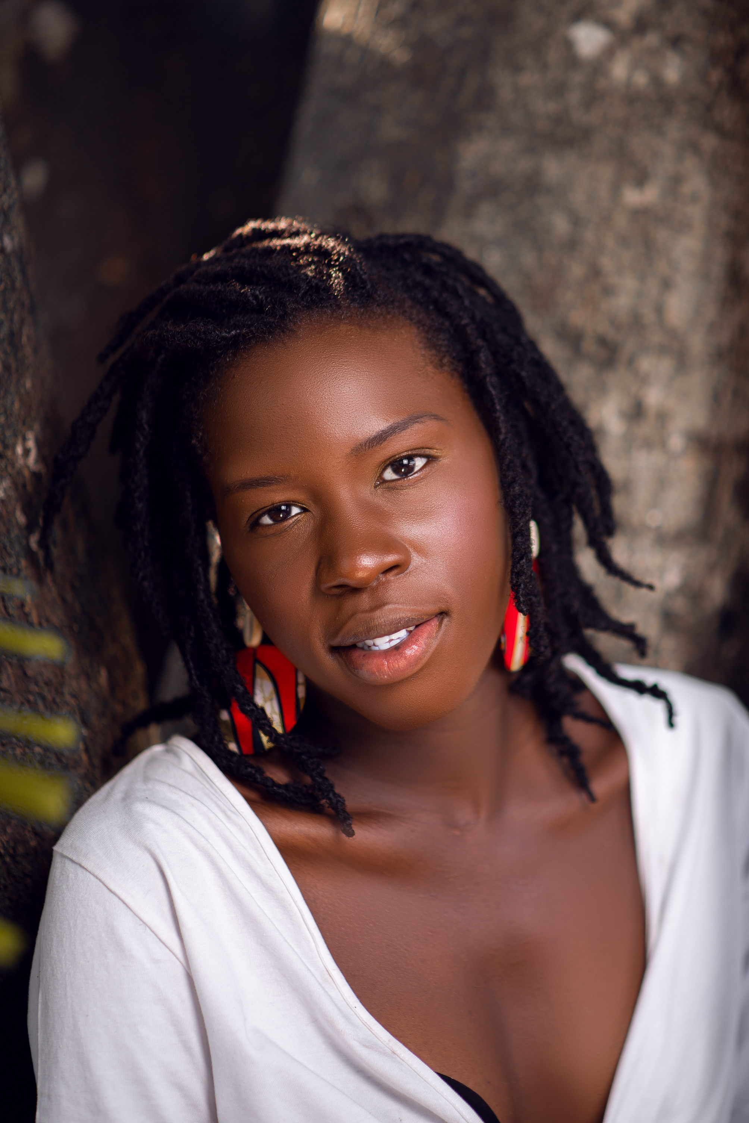
Name
Information
Contact Way
NTSEKE NGONGO
Jackie Michelle

2019-2021 AMILCAR CABRAL AGRICULTURAL VOCATIONAL HIGH SCHOOL (LEPAAC)
🔵 Baccalaureat: production and animal health option
- Third Winner of "tremplin mboté hip hop" compétition slam category organized by french cultural center of Brazzaville and VIVENDI CREATE JOY
- First place of the entrance exam to the national higher School (ENSAF)

- Quite good English level in writing and speaking
- public speaking, Poetry, stylism
+242 065198284
jackie.m.slam@gmail.com

Age：22
Living：CONGO BZV

Education

Skills
Introduction

Honors

As passionnately driven and highly motivated individual, I am deeply committed to addressing pressing global challenges such as climate change and children's right. With a strong sense of determination and unwavering dedication, I am eager to leverage my skills and experience to make a meaningful impact in tackling these critical issues. My mission is clear: to be a proactive agent of change and advocate for a more sustainable future for our planet.

、
2021-2024 UNIVERSITY OF MARIEN NGOUABI
NATIONAL HIGHER SCHOOL OF AGRONOMY AND FORESTRY (ENSAF)
🔵Licence (level3, in course): animal production and health option

2019- 2023 AMILCAR CABRAL AGRICULTURAL VOCATIONAL SYLVO AGRO-PASTORAL HIGH SCHOOL (LEPAAC)
🔵 Technical study patent : agriculture option

